



**ONLINE PROJECT TRACKING**

**SYSTEM**

**A MINI PROJECT REPORT**

***Submitted by***

|  |  |
| --- | --- |
| **P.ROHAN** | **(710720205042)** |
| **R.SRIDHAR** | **(710720205053)** |
| **A.MOHAMED HAMJA YUSUF** | **(710720205302)** |

***in partial fulfilment for the award of the degree***

***of***

**BACHELOR OF TECHNOLOGY**

# in INFORMATION TECHNOLOGY

**Dr. N.G.P. INSTITUTE OF TECHNOLOGY, COIMBATORE – 641048 (An AUTONOMOUS INSTITUTION)**

**ANNA UNIVERSITY: CHENNAI 600 025**

# MAY 2023

**ANNA UNIVERSITY: CHENNAI 600 025**

**BONAFIDE CERTIFICATE**

Certified that this mini project report **“ONLINE PROJECT TRACKING**

**SYSTEM”** is the Bonafide work of **“P. ROHAN (710720205042), R. SRIDHAR** **(710720205053), A. MOHAMED HAMJA YUSUF (710720205302)”** who carried out the project under my supervision.

|  |  |
| --- | --- |
| **SIGNATURE** | **SIGNATURE** |
| **Dr. M. KRISHNAMOORTHI M.E., Ph.D.,** | **Ms. A. KAVITHA** |
| **PROFESSOR & HEAD**  Department of Information Technology, Dr. N. G. P Institute of Technology, Kalapatti Road,  Coimbatore-641 048. | **SUPERVISOR**  Assistant Professor (SS),  Department of Information Technology, Dr. N.G.P Institute of Technology,  Kalapatti Road, Coimbatore-641 048. |

Submitted for the Mini Project Viva-Voce held on

**_ _ _ _ _ _ _ _ _ _ _ _ _ _ _ _ _ _ _ _ _ _ _ _ _**

# INTERNAL EXAMINER EXTERNAL EXAMINER

**ACKNOWLEDGEMENT**

We extend our heartiest thanks to **Dr. NALLA G. PALANISWAMI**, Chairman, KMCH & Dr. N.G.P. Educational Institutions for providing us the necessary infrastructure to do our project work.

We express our gratitude to **Dr. THAVAMANI D. PALANISWAMI**, Secretary, Dr. N.G.P. Institute of Technology, for providing us the facilities to do our project work.

We would like to express our hearty thanks and gratitude to **Dr. S. U. PRABHA, M.E., Ph.D.,** Principal, Dr. N.G.P. Institute of Technology, for her earnest encouragement.

We extend our deep sense of gratitude to **Dr. M. KRISHNAMOORTHI, M.E., Ph.D.,** Head of the Department, Department of Information Technology, for his valuable guidance and constructive suggestion at all stages of our project from inception to completion.

We express our hearty thanks to our project guide, **Ms. A. KAVITHA,** Assistant Professor (SS), Department of Information Technology, for her valuable guidance and timely help for completing our project.

We express our sincere thanks to our mini project coordinator **Ms. BIJI ROSE, M.E.,** Assistant Professor (SG), Department of Information Technology, for her support in developing our project.

We would also like to express our gratitude to the faculty members of Department Information Technology and also to our family for their kind patronage.

# ABSTRACT

Online Project Tracking System is to showcase the projects done by the students. There are some ways to store the projects - as a hard copy, as a CD/Document in a library. Since these are not able to access at any time, the project tracking system can maintain the details of the project to view at any time. The project is aimed to reduce the time for searching a project in the library. The system is developed to store and view the projects in a web portal built using HTML, CSS & JAVASCRIPT and SQL for database connectivity. The project comprises of student and admin module who can login to the web portal with registered credentials. This way it reduces the workload of maintaining all the projects manually.

**KEYWORDS**: Website, Showcase the projects, Maintaining the projects.

# 

**TABLE OF FIGURES**

|  |  |  |
| --- | --- | --- |
| **FIGURE NO** | **FIGURE NAME** | **PAGE NO** |
| 4.1 | Admin framework | 8 |
| 4.2 | Student framework | 9 |
| 6.1 | Experimental result | 12 |
| 6.2 | Login page | 13 |
| 6.3 | Sign in page | 14 |
| 6.4 | Dashboard page | 15 |
| 6.5 | Displaying page | 16 |
| 6.6 | Detailed page | 17 |

**CHAPTER – 1 INTRODUCTION**

Now a days, there are so many projects done by the students stored only in a physical copy. Searching those projects in a college library is a difficult task and also storing and maintaining those records is a very difficult job. As a result, it is necessary to automate into a digital format which is how the Project Management System works. It provides librarian to monitor the overall project activities. Also, the admin can able to communicate with the students, provide feedbacks, view the status of the projects and guide them when needed.

# 1.1 OBJECTIVE

* To view projects which were done by the students through online.
* It also builds a website to showcase the projects and reduce the work of searching in the library.
* To maintain each and every project and its details project-related documents, such as progress reports, and final draft through online.
* The system generates comprehensive reports and documentation related to project progress, performance, and outcomes.
* It provides information on resource availability, utilization, and allocation to specific tasks.
* It provides a platform to log and monitor issues, assign responsibility for resolution.
* To enhances transparency, promotes teamwork, and reduces communication gaps.

# 

# CHAPTER – 2 LITERATURE SURVEY

**2.1. INTRODUCTION**

The innovative ideas and concepts which helped for the proposal of the system were taken from the following references. This has helped in gaining information regarding the works and procedures of the existing systems. Encapsulating the advantages and disadvantages of various existing systems henceforth helped in modifying the project.

# 2.2 LITERATURE REVIEW

1. From the study on the student management system, it is observed that the system uses B/S Architecture works as client/server architecture in which it mainly contains increased bandwidth usage and potential latency issues, especially when dealing with large data transfers or high user loads and cannot capable of handling large amount of data such as encrypting and decrypting those data. Since the code was written in C# language, the work efficiency is low.
2. It is mainly noted that the entire system mainly focuses on the databases. Only book availability can be checked in online. It does not contain any project related works, only a smaller number of books were stored as an E-format to read and it has built only to use within the department. It is also proposed that the technical glitches arise when organizing many databases.
3. The Collaborative Project Management (PM) mainly focused in the areas of computerized PM has focused on the automation of scheduling and planning, and adopted single-user or single- project perspective. It also noted that the progress cannot be viewed while developing the project. Technical issues, system downtime, or slow network connections can disrupt team collaboration and hinder productivity and it is highly reliable in high usage of network.
4. In the LMS using IoT, it cannot be implemented on a minimal budget. However, the Cost of Implementation is high and the system may get too complex for the users to access the system. From the study on Advanced LMS, it is noted that the integrating IoT devices with existing library systems and databases can be challenging. Maintaining the IoT devices is more complex than the traditional Library.
5. The LMS had been developed with cloud computing such as the Software as a Service (SaaS)delivery model depicts how college libraries could form library consortium at its own private cloud environment with installation of the required LMS application, database, middleware and other prerequisites. From the study it is noted that the cloud-based approach can be very complex in terms of physical setup of the proper installation and considering the cost to integrate all the existing data is a difficult job.
6. Project Management Institute (PMI) in their PMBOK GUIDE defines project management system as software that has the ability to help strategize, organize, and manage resource streams and develop resource approximations. Depending on the complexity of the software, resource breakdown structures, resource availability, resource rates and various resource calendars can be defined to assist in optimizing resource utilization.

# 

# CHAPTER-3

# SYSTEM ANALYSIS

* 1. **EXISTING SYSTEM**

Now a days students need to physically search in a library for projects. But most of the time it is a very tedious job to search the projects and the librarian needs to organizes those project reports either as a CD/Document type. While developing a project it is not always visible/ transparent progress with the students and the project Guide. The projects done by other departments are not transparent and it is confined within a single department. It also results in the lacking of collaborative workplace with other departments. Also, the progresses of certain projects are always needs to update to the project guide manually.

* + 1. **DRAWBACKS OF EXISTING SYSTEM**

In existing system, the accuracy is low when compared to our system. Invasive method is mostly used in the existing system and more man power is required. Traditional project management systems may not offer robust collaboration features, resulting in limited real-time communication and collaboration among team members.

Tracking project progress and identifying bottlenecks or delays may be challenging, leading to a lack of real-time visibility into project status.

# PROPOSED SYSTEM

Project Management System (PMS) propose result to the drawbacks of the existing methods such as organizing many project databases and creates a user-friendly interface to display the projects separated and classified under each department.

By this project students can also create, edit projects. When it comes to developing, admin plays a main role in this system where the project status can be viewed and feedback can receive to the students at any time. Also, it is capable of creating virtual task boards where students can visualize and track project tasks.

The time planner plays a major role while developing a long term or short-term project, it automatically creates a work flow where the students and also guides can collaborate from Inception phase to Deployment. It also ensures that it uses cloud-based document sharing platforms like Google Drive, drop box, or Microsoft One Drive to store and share project- related documents. This ensures that all team members have access to the latest project files and can collaborate effectively. As the system is mainly build using HTML, CSS and JS for front end and SQL for the database. It tends to be simple web-based portal just to showcase the previous year projects done by the students and used as a planner for creating a project from the start to the end. It saves students time and can retrieve any related documents at any time. This makes system highly accessible and eliminates the need for installation or frequent software updates on individual devices.

# SYSTEM DESIGN

* + 1. **WEB APPLICATION**

The proposed web application use admin and student for the operations to be performed. Once the student/admin registered or login using their Email, it redirects into the web application where it produces all data such as Department and project details maintained with the user-friendly interface that allows users to navigate and interact with the application easily.

# 3.3.2 DATABASE

Database handlers create database in such a way that only one set of software program provide access of data to all the users. In this web portal we used MySQL for organizing large amount of data. In this web application it also needs to store and update frequently of

the progress of the projects.

* 1. **LIST OF MODULES**
     1. **REGISTRATION PAGE**

In this web application a new student/guide needs to register using basic credentials like name, email id and other details. Once the new user (Student/guide) registered into the web application, it redirects them into the home page where all the projects were organized and displayed.

# LOGIN PAGE

Once the user already has been registered, they can login using e-mail id and it can easily use to retrieve their current working of projects where their entire project related data were stored. The students can easily retrieve their data and resumes working at any time.

# DASHBOARD PAGE

This module represents the dashboard. User-friendly interfaces and appealing design are important components of the user experience in this application. It is also one of the most important factors in the success of this service. The ultimate goal of a good user interface is to make user interaction as easy, direct, and efficient as possible. It contain

the all the project details developed by the students.

# DISPLAY PAGE

This module represents the display page where all of the student projects were organized and maintained. In this page the students can view many projects. Once the project is clicked it directs to the detailed page where the project details such as Abstract, Authors can be viewed in the page. It shows the detailed page of the project.

**CHAPTER-4**

**FRAME WORK**

**4.1 ADMIN**

This module shows the admin framework and the actions that can be performed by the admin. There are various actions can be performed by the admin like view the projects, view source code, and can also able to change password.

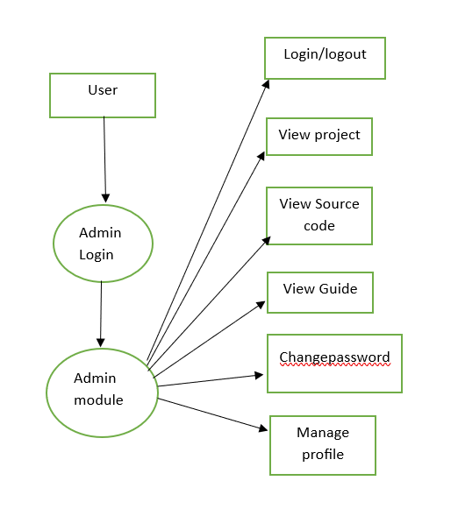

**Fig 4.1 ADMIN FRAMEWORK**

# 4.2 STUDENT

This module shows the student framework and the actions that can be performed by the admin. There are various actions can be performed by the students like view available projects, manage profile, and can also able to change password.

# 

**Fig 4.2 STUDENT FRAMEWORK**

# CHAPTER-5

# SYSTEM SPECIFICATION

* 1. **INTRODUCTION**

A clear view of the hardware and software requirements of the project is crucial to understand its commissioning and working. The chapter takes a deep analysis of the various hardware and software requirement for the proposed system.

# 5.2. HARDWARE SPECIFICATION

This section gives the details and specification of the hardware on which the system is expected to work.

* RAM : 8GB
* Data set Storage : 2 GB
* CPU : 2 GHz
* Architecture : 64-bit,
* minimum core : i3 processor,
* Program Storage Maximum : 50mb

# SOFTWARE DESCRIPTION

A software requirements specification is a description of a software system to be developed. It lays out functional and non-functional requirements and may include a set of use cases that describe user interactions that the software must provide. The software requirements are description of features and functionalities of the target system. Requirements convey the expectations of users from the software product.

# SOFTWARE SPECIFICATION

* + - Visual studio code
    - Html
    - CSS
    - MySQL

# 

# 5.3.2. HTML

HTML (Hyper Text Markup Language) is used to structure a web page and its content. For example, content could be structured within a set of paragraphs, a list of bulleted points, or using images and data tables.

It's the fundamental technology behind everything you see in a web browser, and it's used to build everything from simple web pages to complex web applications and services. HTML elements form the building blocks of all websites. HTML allows images and objects to be embedded and can be used to create interactive forms.

# 5.3.3 CSS

Cascading Style Sheets (CSS) is a style sheet language used for describing the presentation of a document written in a markup language such as HTML. CSS is a cornerstone technology of the World Wide Web, alongside HTML and JavaScript.

CSS is designed to enable the separation of presentation and content, including layout, colors, and fonts. This separation can improve content accessibility; provide more flexibility and control in the specification of presentation characteristics; enable multiple web pages to share formatting by specifying the relevant CSS in a separate .CSS file, which reduces complexity and repetition in the structural content; and enable the .CSS file to be cached to improve the page load speed between the pages that share the file and its formatting.

# 5.3.4 MySQL

A relational database organizes data into one or more data tables in which data may be related to each other; these relations help structure the data. SQL is a language programmers use to create, modify and extract data from the relational database, as well as control user access to the database. In addition to relational databases and SQL, an RDBMS like MySQL works with an operating system to implement a relational database in a computer's storage system, manages users, allows for network access and facilitates testing database integrity and creation of backups.

# CHAPTER-6 RESULT AND OUTPUT

**6.1. RESULT**

The project management system has proven to be effective in achieving its intended purpose. The system has significantly reduced the amount to time required for project search and manage projects, freeing up library staff to focus on other tasks. The system’s comprehensive database has eliminated errors in record-keeping and made it easier to track projects materials and user records. The system has also improved the user experience by providing a more user- friendly interface and offering features such as project searching and develop.

The system was tested and refined based on feedback from the students and the library staff. By using the system, we were able to significantly reduce the time spent on searching in library. The system’s tracking feature allowed users to quickly identify the projects and develop the projects. The proposed web application can use admin and user for the operations to be performed.

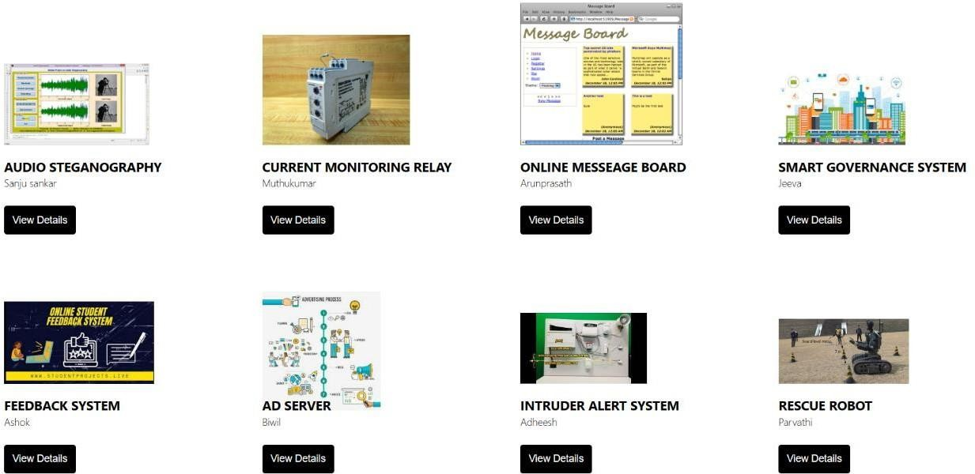

**Fig 6.1 OUTPUT SCREEN**

The system displays the available projects in the library and helps the user to search the projects in the library.

# 6.2 OUTPUT SCREEN

The aim is to display the available projects in the library in the website using html, CSS based on the library management system. To get this done, various modules in html were imported.

Visual studio code is used for execution. HTML is used to display the projects and CSS is used to design the website. The system has various pages like

* Login page
* Sign in page
* Dashboard page
* Display page

# 6.2.1 LOGIN PAGE:

This module represents the login screen. The login page allows a user to gain access according to their position. There are 2 login phases

1. Student
2. Admin.

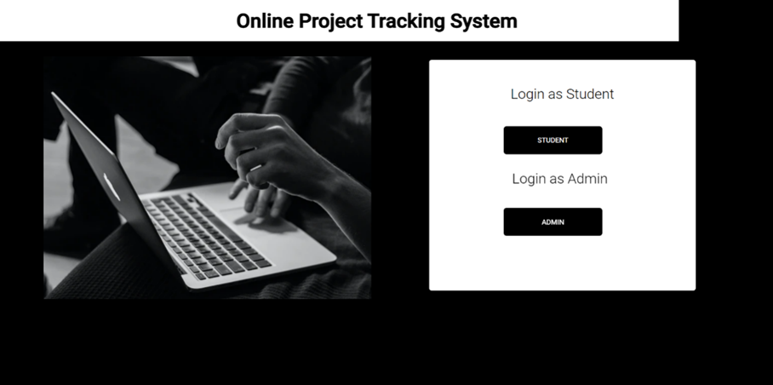

**Fig 6.2 LOGIN PAGE**

# 6.2.2 SIGN IN PAGE:

This module represents the login screen. The login page allows a user to gain access to an application by entering their email id, password to navigate the application. The password can contain all the characters, letters, symbols as well as marks. There is an option to see the entered password in the dashboard.

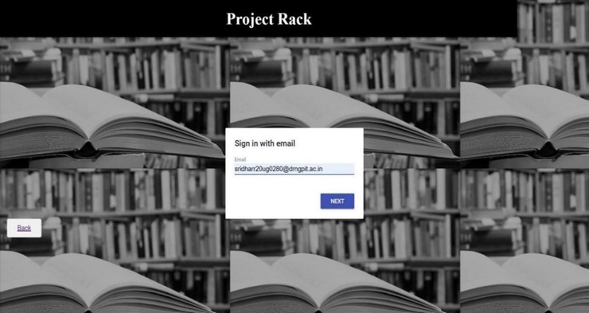

**Fig 6.3 SIGN IN PAGE**

# 6.2.3 DASHBOARD PAGE

This module represents the dashboard. User-friendly interfaces and appealing design are important components of the user experience in this application. It is also one of the most important factors in the success of this service. The ultimate goal of a good user interface is to make user interaction as easy, direct, and efficient as possible.

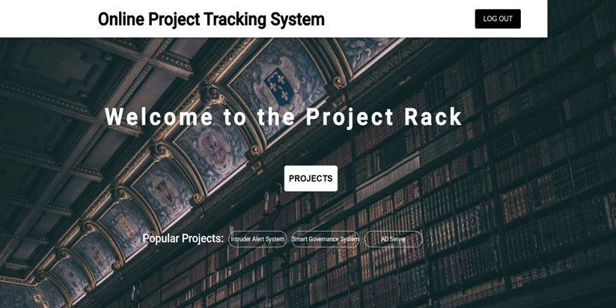

**Fig 6.4 DASHBOARD PAGE**

# 6.2.4 DISPLAYING PAGE:

This module represents the available projects. It is the main page of the application it contains the all the projects.



**Fig 6.5 DISPLAYIG PAGE**

# 6.2.5 DETAILED PAGE:

This module represents the detailed about the projects displayed in the previous

screen.

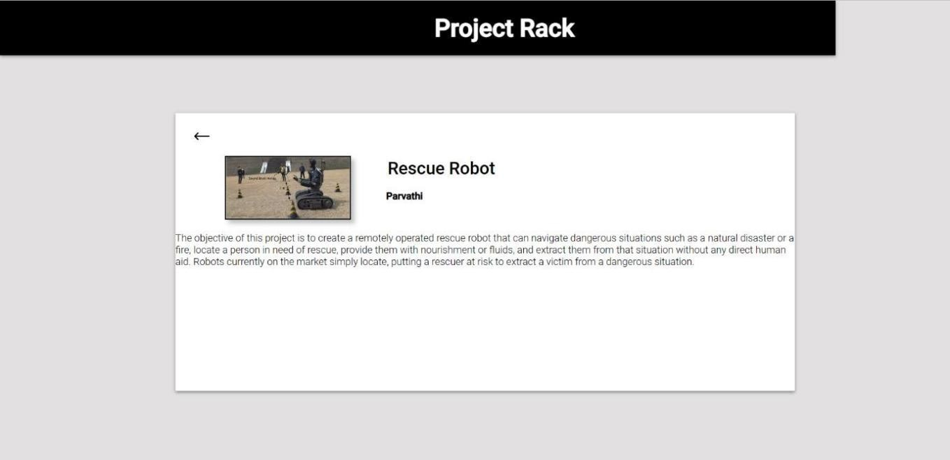

**Fig 6.6 DETAILED PAGE**

# CHAPTER-7 CONCLUSION AND FUTURE WORK

* 1. **CONCLUSION**

This web-based application will be helpful to the students to get a working experience about many projects. It promotes transparency, collaboration and efficiency to work on a project and student’s related document and work progress will be available on this application. It helps to make communication easy with the project guide and also within the students. The above proposed system will help the Project Tracking system to work efficiently. Also, with using these proposed methods, it is also focused on to store projects database. When using this web application, it creates an easy and user-friendly platform to collaborate with one another and to get a knowledge about working in many projects and to gain an experience where efficient work progress, developing communication with fellow students and also to make every step of the projects visible to the team.

# FUTURE WORK

Even with these proposed methods in the Project Tracking System, the system works well and efficiently. But maintain the database is a huge task and day by day growing of database needs to well monitored and maintained. Such developing system will be proposed in the future usage. And the progress monitoring tools needs to be updated to make the work visible to the team and it can be implemented in the future usages.

# REFERENCES

1. Lloyd-Walker, B., French, E., & Crawford, L. (2016). Rethinking researching project management: Understanding the reality of project management careers. International Journal of Managing Projects in Business, 9(4), 903-930.
2. Morris, P. W. (2010). Research and the future of project management. International journal of managing projects in business, 3(1), 139-146.
3. Peerzade, S., Andewale, A., & Jamidar, S. (2023). A Web Application based Automated E-Library Management System. Journal of Web Development and Web Designing, 8(1), 34-41.
4. Winston, M. D., & Hoffman, T. (2005). Project management in libraries. Journal of library administration, 42(1), 51-61.
5. Shenhar, A. J., & Dvir, D. (2007). Project management research—The challenge and opportunity. Project management journal, 38(2), 93-99.
6. Moesby, E. (2002). The process towards implementing problem-based

learning. Reflections on PBL. A Republic Polytechnic Publication. Newsletter issue, (1).

1. Kwak, Y. H., & Anbari, F. T. (2009). Analyzing project management research: Perspectives from top management journals. International journal of project management, 27(5), 435-446.Li, F. (2022).
2. Research On the Management System Of College Students’ Innovation And Entrepreneurship Education Based On B/S Architecture. Journal of Applied Science and Engineering, 26(5), 597- 604.
3. Shaw, J. N., & De Sarkar, T. (2021). A cloud-based approach to library management solution for college libraries. Information Discovery and Delivery, 49(4), 308-318.
4. Kim, C., Jeon, J., & Kim, M. S. (2015). A project management system based on the PMBOK guide for student-centered learning. International Journal of Knowledge Engineering, 1(3), 185-190.
5. Bharamagoudar, S. R., Geeta, R. B., & Totad, S. G. (2013). Web based student information management system. International Journal of Advanced Research in Computer and Communication Engineering, 2(6), 2342-2348.